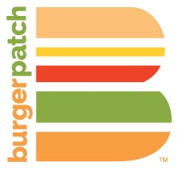 | We are offering our  Vegan Chef Challenge Menu  Midtown – 2301 K Street  11am-10pm (Sun-Thu)  11am – 12am (Fri-Sat)  East Sacramento – 1420 65th Street  11am – 10pm  Davis – 500 1st Street  11am – 10pm (Sun-Thu)  11am – 11pm (Fri-Sat) | 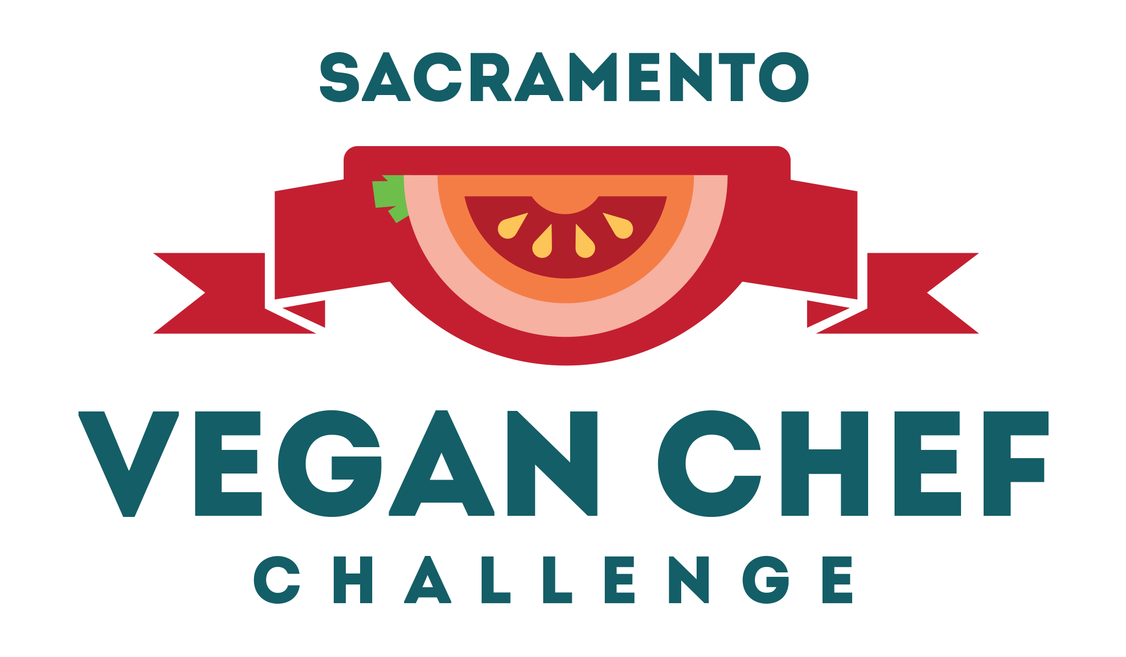

Our Special Vegan Chef Challenge Dishes
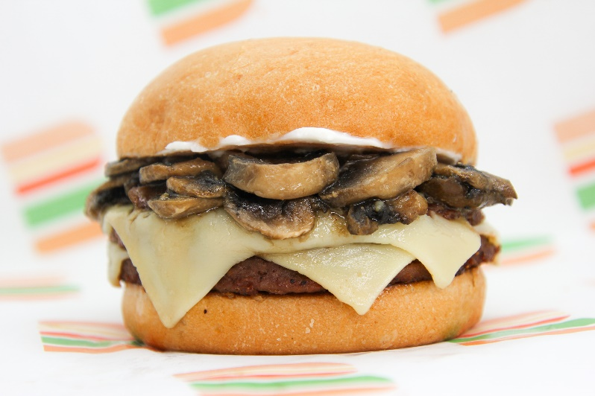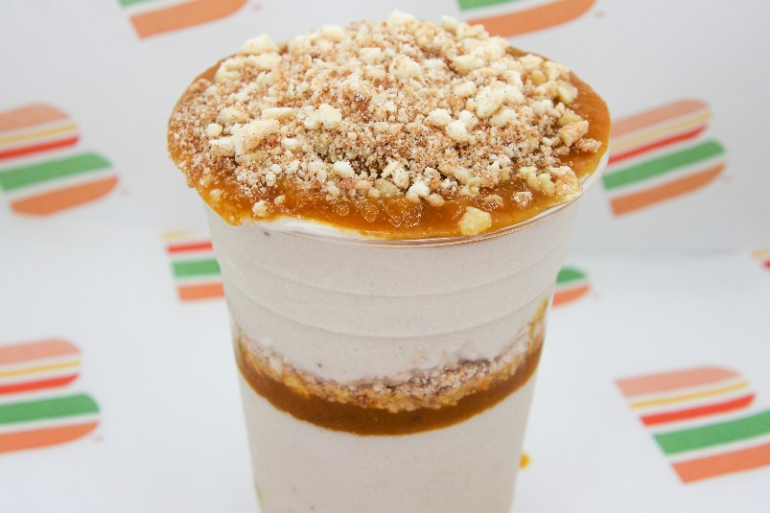 | Mushroom Swiss Patch Burger  House-seasoned grilled patty with savory sautéed seasoned mushrooms, house mayo and a slice of swiss on a locally baked grilled artisan bun.  Contains gluten, soy. GF option  $8.90 Single / $11.90 Double  Pumpkin Patch Shake (gf)  Our homemade shake with two layers of all-natural house blended pumpkin sauce topped with crunchy cinnamon sugar crumble. Choose: vanilla, chocolate, 50/50  *Contains soy, cashew & almond  $7.50

